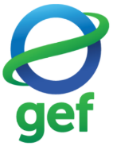

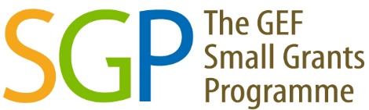

2020-2025
SMALL GRANTS PROGRAMME
COUNTRY RESULTS MONITORING REPORT

CAMBODIA

COUNTRY PORTFOLIO
Country Programme | Cambodia
Year Started | 2005
Portfolio since Inception | GEF |  | Non-GEF |  | Total
Number of projects | 138 |  | 143 |  | 281
Grant amount committed | 4,756,813 |  | 5,394,069 |  | 10,150,882
Project level co-financing in cash | 2,092,141 |  | 903,278 |  | 2,995,419
Project level co-financing in kind | 3,257,853 |  | 3,050,463 |  | 6,308,316
Source: SGP database as of September 2025
 | July 2020 - June 2021 | July 2021 - June 2022 | July 2022 - June 2023 | July 2023 - June 2024 | July 2024 - June 2025 | Total  2020 - 2025
Focal Area Distribution (by completed GEF projects)
Biodiversity | 6 | 1 | 3 | 7 | 4 | 21
Climate Change | - | 2 | - | 1 | 1 | 4
Capacity Development | 2 | - | - | 1 | - | 3
International Waters | - | 3 | - | - | - | 3
GEF Projects Completed | 8 | 6 | 3 | 9 | 5 | 31
Source: Reporting by Country Programme as part of the Annual Monitoring Process. Verified/updated in previous country monitoring reports.

RESULTS ACHIEVED 2020-2025
Kindly note that the values 2020-2025 have undergone quality assurance by SGP country teams in previous process of producing Country Results Monitoring Report
 | July 2020 - June 2021 | July 2021 - June 2022 | July 2022 - June 2023 | July 2023 - June 2024 | July 2024 - June 2025 | Total  2020 - 2025
PROGRESS TOWARDS FOCAL AREA OBJECTIVES
Biodiversity
Number of Biodiversity projects completed | 6 | 1 | 3 | 7 | 4 | 21
Number of Protected Areas (PAs) positively influenced | 2 | - | 2 | 3 | 1 | 8
Hectares of PAs | 1,925 | - | 181,207 | 16,105 | 10,658 | 209,895
Number of ICCAs positively influenced | - | - | 3 | 4 | - | 7
Hectares of ICCAs | - | - | 5,969 | 4,705 | - | 10,674
Number of biodiversity-based products sustainably produced | - | - | - | 1 | - | 1
Number of significant species conserved | 7 | - | 5 | 6 | 10 | 28
Number of target landscapes/seascapes under improved community conservation and sustainable use | 1 | - | 3 | 3 | 2 | 9
Hectares of target landscapes/seascapes | 4,135 | - | 564,088 | 77,275 | 11,687 | 657,185
Climate Change
Number of Climate Change projects completed | - | 2 | - | 1 | 1 | 4
Addressing community-level barriers to deployment of low-GHG technologies? | - | Yes | - | Yes | - | 2
Hectares of forests and non-forest lands with restoration and enhancement of carbon stocks | 7,866 | 776 | 145,254 | - | 712 | 154,608
Number of typologies of community-oriented, locally adapted energy access solutions with successful demonstrations or scaling up and replication | - | 3 | - | - | 1 | 4
Number of households achieving energy access co-benefits | - | 396 | 48 | - | 547 | 991
Breakdown of projects
Low carbon technology and renewable energy projects | - | 2 | 1 | - | 1 | 4
Conservation and enhancement of carbon stocks projects | - | - | 4 | - | 1 | 5
Sustainable Forest Management
Hectares restored through improved forest management practices | 7,866 | - | - | - | - | 7,866
International Waters
Number of international waters projects completed | - | 3 | - | - | - | 3
Number of seascapes/inland freshwater landscapes | - | 1 | - | N/A | - | 1
Land based pollution reduced (tons) | - | 958 | - | - | - | 958
Hectares of marine/coastal areas of fishing grounds brought under sustainable management | - | 1,793 | - | - | - | 1,793
Chemicals and Waste
Number of national coalitions and networks on chemicals and waste management established or strengthened | - | 1 | - | - | - | 1
Community-Based Tools/Approaches Deployed as Part of the Portfolio
Sustainable pesticide management | - | Yes | Yes | - | - | 2
Organic farming | Yes | Yes | Yes | - | - | 3
Development of alternatives to chemicals | - | Yes | - | - | - | 1
Awareness raising and capacity development | Yes | Yes | Yes | - | - | 3
Capacity Development
Number of Capacity Development projects completed | 2 | - | - | 1 | - | 3
Number of civil society organizations with strengthened capacities | - | - | - | 10 | - | 10
Number of community-based organizations with strengthened capacities | - | - | - | 20 | - | 20
Number of people with improved capacities to address global environmental issues at the community level | - | - | - | 23 | - | 23
GRANTMAKER PLUS
CSO-Government Dialogue
Number of CSO-government dialogues supported | 2 | 4 | 1 | 9 | - | 16
Number of CSO/CBO representatives involved in the dialogues | 370 | 189 | 181 | 1,880 | - | 2,620
Gender
Number of gender responsive completed projects | 8 | 5 | 2 | 7 | 5 | 27
Number of completed projects led by women | 1 | 1 | 2 | 2 | 2 | 8
Programme Management: NSC gender focal point (yes/no) | Yes | Yes | Yes | Yes | Yes | 5
Indigenous Peoples
Number of completed projects that included indigenous peoples | 2 | 2 | 3 | 3 | - | 10
Number of indigenous leaders with improved capacities | - | 15 | 3 | 4 | - | 22
Programme Management: NSC IP focal point (yes/no) | Yes | Yes | Yes | Yes | - | 4
Ways to encourage IP projects
Proposals accepted in local languages (yes/no) | Yes | Yes | Yes | Yes | Yes | 5
Involved indigenous peoples in NSC and/or TAG (yes/no) | Yes | Yes | Yes | - | Yes | 4
Enhanced outreach and networking with indigenous people’s groups (yes/no) | Yes | Yes | Yes | Yes | Yes | 5
Youth
Number of completed projects that included youth | - | - | - | 1 | - | 1
Number of youth organizations | - | - | - | 1 | - | 1
Programme Management: NSC youth focal point (yes/no) | Yes | Yes | Yes | - | Yes | 4
BROADER ADOPTION (Scaling up, Replication, Policy Influence, Improving Livelihoods)
Projects replicated or scaled up | 2 | - | - | - | - | 2
Projects with policy influence | - | - | - | 1 | - | 1
Projects improving livelihoods of communities | 6 | 5 | 3 | 9 | 5 | 28
PROGRAMME EFFECTIVENESS
Peer-to-peer exchanges conducted | - | 5 | 58 | 7 | 5 | 75
Community-level trainings conducted | 6 | 15 | 3 | 4 | 4 | 32
Number of projects monitored through field visits | 7 | 7 | 10 | 8 | 12 | 44
PROGRAMME MANAGEMENT
National Steering Committee
Number of NSC meetings occurred during the reporting period | 7 | 8 | 7 | 8 | 10 | 40
Average number of NSC members that participated in each NSC meeting | 7 | 7 | 7 | 8 | 8 | 7
Average time in days needed to replace NSC member | 60 | 60 | 2 | 150 | 90 | 72

GRAPHICAL REPRESENTATION OF KEY RESULTS
The bars in the graphs indicate the number of years that the country programme has achieved specific results. If a bar is absent, it indicates that while the associated result is not observed in the country programme, it is still evident in the overall aggregated SGP portfolio.

EXAMPLES OF PROJECT RESULTS

Biodiversity
In Cambodia, a project completed by Sansom Mlup Prey Organization improved communities’ livelihoods and supported conservation through promoting growing organic wildlife-friendly rice (IBIS Rice). The project's success was achieved for the community members residing in the seven targeted villages who participated as IBIS members. To become IBIS members, farmers were required to sign a contract annually, pledging adherence to the 12 rules of the IBIS rice project, primarily related to conservation regulations in the Siem Pang Wildlife Sanctuary. The project diligently mapped all farmlands of the IBIS members using GIS technology to ensure their legality and compliance with the conservation rules. Strict monitoring of the farmlands helped prevent illegal land expansion, hunting, logging, and the use of chemical inputs. The project's mechanisms also ensured that members understood and followed the conservation rules, contributing to the conservation of wildlife and forests in the sanctuary.
As a result, the project recruited 143 new IBIS members, bringing the total number of IBIS rice households to 704 in the seven targeted villages by February 2023. Of these registered members, 594 households complied with wildlife-friendly rules after undergoing inspection, resulting in a compliance rate of 99.83% with IBIS project regulations. Through the project's efforts, these compliant households sold back a total of 914 metric tons of organic paddy rice to the IBIS Rice Conservation Company (IRCC), receiving a premium price of an average of 1,750 KHR/kg (0.42 USD/kg), which was 59% higher than the local market price. This generated a significant income of USD 425,917 from IBIS Rice sales for 415 IBIS members, averaging to approximately USD 944 per household. (Source: Annual Monitoring Report, 2022-2023)

Sustainable Land management
In Cambodia, SGP supported grantee, My Village Organization to help Prov Indigenous People and Community Forestry (CF) committee members in the implementation of sustainable forestry resource management that conserved 1,073.08 hectares of forestry area, with the ultimate objective to reduce the pressure on forest exploitation and increase income. In the country, forests were extremely important for the livelihood and well-being of the population. 85 percent of Cambodians lived in rural communities, and they were heavily reliant on forest resources to meet their daily substance needs. However, inadequate policies and forest management escalated in loss of forest resources, environmental degradation and exploitation as well economic insecurity for the local population. Rural communities reported low productivity with 9 chickens per household, 40% chicken mortality, 0.1 ha of cultivated land per household, productivity of 0.26 ton per hectare and 30% of vegetable productivity loss due to pest destruction.

The project provided support to 120 families by offering technical assistance to diversify crops and improve agricultural technique, ultimately reducing the pressure on forest exploitation. It also enhanced CF recognition from relevant stakeholders, particularly the Ministry of Agriculture, Forestry and Fisheries (MAFF); rehabilitated and improved the community-based water reservoir and water gate in order to enable access to water for household consumption and irrigation. As long-term results, the project will also contribute to the Provincial Development Plan (2020-2024), the Commune Development Plan (2020-2024), the Commune Investment Programme (2020-2024) regarding the protection of natural resources and water supply as well as working towards the achievement of SDG 1, SDG 2, SDG 6 and SDG 15. (Source: Annual Monitoring Report, 2020-2021)

International Waters
In Cambodia, the Action for Research and Development completed a project strengthening community capacity for mangrove conservation in Prey Nup District, Preah Sihanouk Province. In the district, littering was the main challenge, which flows into the sea through canals and seriously affected marine biodiversity and the well-being of local people. Two meetings were organized with the participation of Agriculture, Environment and Natural Resource Officers of Prey Nup district, Commune Councilors, community representatives, and representatives from waste collection companies. As results, contracts were signed with waste collection companies. A total of 2 tons of waste in targeted communes (Prey Nup and Toul Tortoeung) are collected daily from the village to the landfill sites designated by district/provincial authorities. In addition, education was conducted by community extension workers at the household level in the two communes on keeping, placing and packaging waste, negative effects of waste, and promoting a better environment. Two community clean campaigns were conducted with the participation of the district governor of Prey Nup, district environment officer, Fisheries Administration officer, commune councilors, police, schoolteachers, students, village security volunteers, business sellers, and local villagers. Plastic bags, bottles, and other plastic trash were collected in public areas including main roads, canals, bridges, etc. It was reported that approximately 1 to 1.5 tons of waste have been collected, packed, and placed in the trash bins properly. As a result, the project has contributed to the implementation of SAP in the South China Sea by restoring and conserving 3,431 hectares of the marine ecosystem, including sustainable use and management of community fishing domain by conducting regular patrolling, conservation of seagrass, and protection of existing mangrove areas and replanting 25,000 small mangrove trees in 15 hectares of degraded areas. (Source: Annual Monitoring Report, 2021-2022)

CSO-Government Dialogue
In Cambodia, the SGP team worked with NGO Forum on the organization of the 9th Farmer Forum on “Smallholder Farmers during COVID-19”. 190 people (73 female), from 14 provinces attended the event, which was chaired by the National Assembly representatives, keynote speakers and representatives of technical institutions. On this occasion, smallholder farmers, civil society organizations, policy research institutes, ministries and development partners had the opportunity to share their views on improving the market demand, promote relevant policies to support Smallholder Farmers during the COVID-19 pandemic, and strength cooperation to help farmers invest in agriculture. As a result of this dialogue, the participants reached the conclusion that key organisations should increase the widespread dissemination of agriculture safety standards, the Ministry of Agriculture should increase funding to support agricultural communities, loan repayments should be postponed, and quality control for fish, meat and vegetable should be strengthened. (Source: Annual Monitoring Report, 2020-2021)

In Cambodia, three regional province workshops on the amendment of the Forestry Law and the Protected Areas Law were organized in collaboration with the NGO Forum on Cambodia and the Secretariat of the National Committee for Sub-National Democratic Development (NCDD) in May 2022. The workshops gathered 15 provincial administrations, provincial departments, and local authorities with a total of 117 participants, 70 representatives of civil society organizations, 9 representatives of indigenous organizations, and 117 community representatives including 53 indigenous peoples. As a result, the workshop organizing committee received a few substantial inputs from stakeholders at the sub-national level to better respond to the management and sustainability of natural resources, as outlined in the entry-level report. With these inputs, in partnership with the Royal Government for the effectiveness of natural resource governance, the NGO Forum on Cambodia and the NCDD will continue the discussions at national workshops with civil society organizations and community representatives on the input for the amendment of the Forestry Law and the Protected Areas Law, aiming to promote the rights of communities in customary tenure, as well as roles and responsibilities of local authorities and stakeholders at the sub-national level in the sustainability of natural resources. (Source: Annual Monitoring Report, 2021-2022)

In Cambodia, under a capacity development project, the NGO Forum on Cambodia (NGOF) organized nine dialogue meetings, influencing four key laws and policies: the Forestry Law, the Protected Area Law, policies on non-timber forest products (NTFPs) commercialization and supply chain management, and strategies related to COP26 outcomes.
During the projects, a workshop was held to explore the feasibility and strategies for the commercialization and supply chain management of NTFPs, bringing together government officials, academia, NGOs, and community leaders. Recommendations from this workshop were incorporated into policy discussions and strategies for NTFP commercialization and supply chain management. Additionally, a consultation workshop was organized to review the key achievements of COP26 and their implications for Cambodia. This hybrid meeting engaged representatives from CSO networks, Indigenous Peoples (IP) organizations, persons with disabilities organizations, technical ministries, and academic institutions. Insights from the workshop informed and influenced Cambodia's engagement with international stakeholders on climate change and environmental issues. To further disseminate knowledge and foster collaborative approaches to environmental governance, NGOF conducted Zoom dialogues to share lessons learned and best practices from the SGP project, facilitating meaningful engagement between CSOs, IPs, government bodies, and international partners. Source: Annual Monitoring Report, 2023-2024)

ALIGNMENT OF OP7 COUNTRY PROGRAMME STRATEGY WITH NATIONAL PRIORITIES
At the national level, GEF focal area strategies and SGP strategic objectives have clear alignment with country priorities and strategies. This CPS is well aligned with the key national priorities such as CBD National Biodiversity Strategy and Action Plan (NBSAP), National Strategic Development Plan (NSDP), Cambodia Climate Change Strategic Plan 2014- 2023, National Policy on Green Growth, Poverty Reduction Strategy Paper (PRSP), National Policy on Rural Electrification by Renewable Energy, National Protected Area Strategic Management Framework (2015) and the National Protected Area Strategic Management Plan (2017-2031) of the government to provide the foundation for planning, designating and managing protected areas that are representative of major ecosystems and well connected. An understanding of the wildlife, habitats and ecosystems to be conserved forms the core of this knowledge base while social, economic and political considerations along with traditional and local community knowledge provide additional layers of important information.
List of relevant conventions and national/regional plans or programmes:
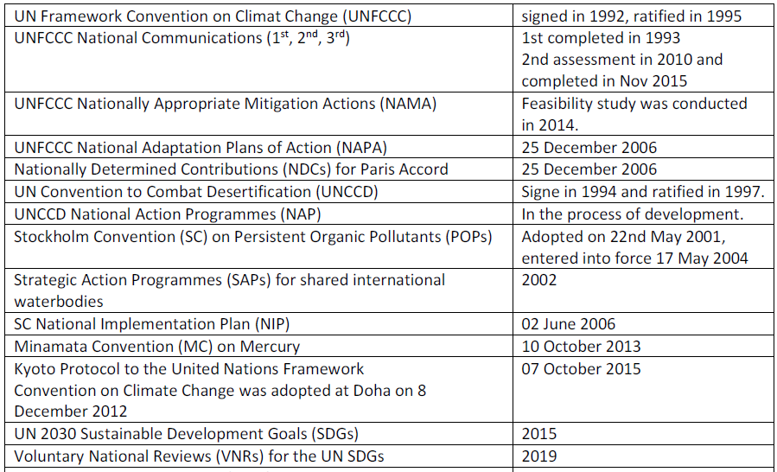
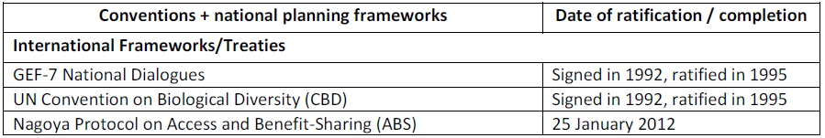

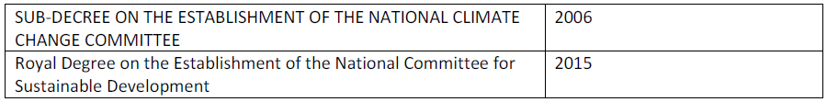
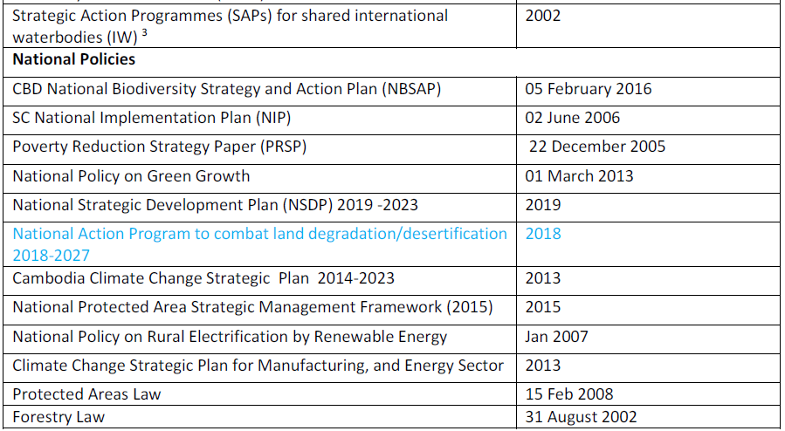
UNDP-implemented Small Grants Programme is delivering integrated results at the country level supporting local level capacities aligned with multiple Multilateral Environmental Conventions. This includes support to work for CBD National Biodiversity Strategy and Action Plan (NBSAP), UNFCCC Nationally Determined Contributions (NDCs), Nationally Appropriate Mitigation Actions (NAMA) and National Adaptation Plans of Action (NAPA), UNCCD National Action Programmes (NAP), and localization of Sustainable Development Goals, amongst many others.

METHODOLOGICAL BASIS OF COUNTRY REPORT
- Results aggregations over time are only for completed projects.

- With SGP's rolling modality, results reflect all ongoing operational phases during the indicated period. Please refer to the total projects completed on the first page for information in this regard.

- The source of reported results is the annual monitoring process, which is part of the annual monitoring requirements for each country programme. Additionally, evaluative evidence sources have also been leveraged, if available for the country programme.

- This results report benefits from extensive quality assurance. All information across all countries in the portfolio is harmonized, verified, and evidenced before being reported. Several layers of this quality assurance have been implemented in the generation of this report and there are no result duplications across years. This point is important not only for a specific unit of measurement (i.e., indicator selected) but also for results aggregation across years in a given operational phase. Reported results include both direct and indirect global-environmental and socio-economic benefits. This is due to SGP's work in two key areas:

- SGP works towards behavioural change at individual, organizational, and community levels. Social determinants that shape human interaction with the environment play an important role, especially at the community level, as sustainability and the continuation of environmental gains often depend on them. These factors include positive shifts in knowledge, attitudes, practices, social and cultural norms, and conventions. Such interventions shape not only demand but also communication between community leaders and other influencers in promoting the adoption of environmentally friendly behaviours and practices. Often, SGP projects have ripple effects that go well beyond the direct scope of the project, emphasizing the importance of measuring indirect impact.

- Encouraging Community Action for Environmental Change. For many years, SGP has focused on promoting and supporting local community groups to bring about broader and sustainable environmental change. This approach is a key aspect of SGP's work and recognizes the power of motivated community groups to create significant impact and drive positive transformation. Community group action refers to informal gatherings of individuals and organizations in the community who share a common belief and purpose. It involves taking practical steps over time to address environmental and socioeconomic challenges and creating positive change. This grassroots-level approach relies on the active involvement and empowerment of the community, with the initial efforts acting as a catalyst for further mobilization. By encouraging self-governance and involving those most affected by the issues, community action can extend its influence to more people in the community, underscoring the importance of measuring indirect impact.

